Javier Jesús Macossay-Hernández EE 348L

April 22, 2016

**Prelab #7**

Exercise 1

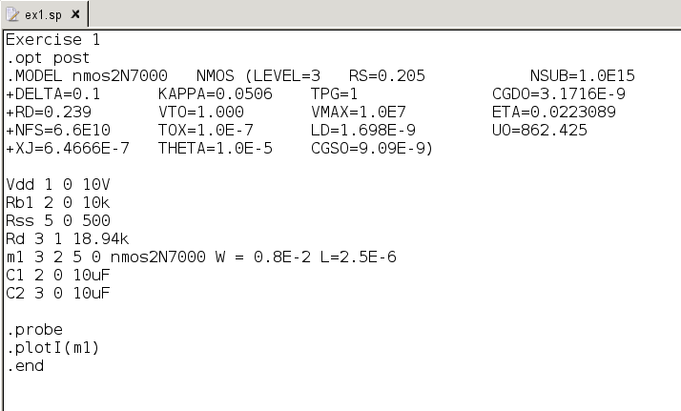

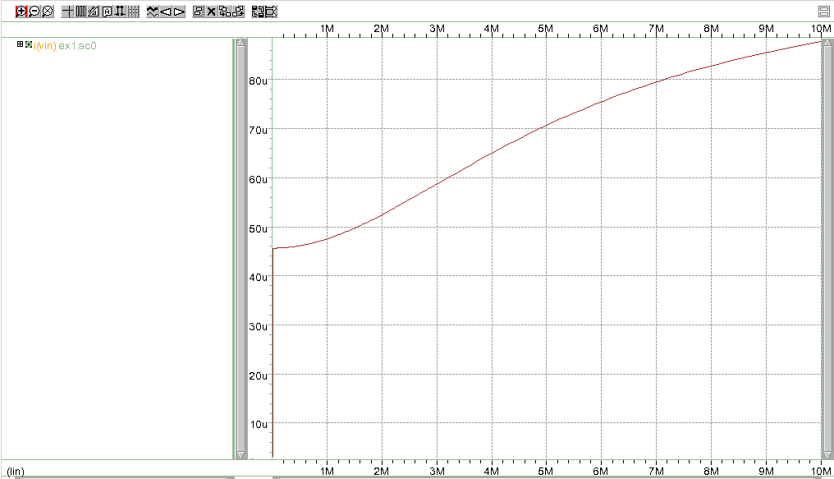

It hits cutoff and the curve can be seen getting flat in saturation.

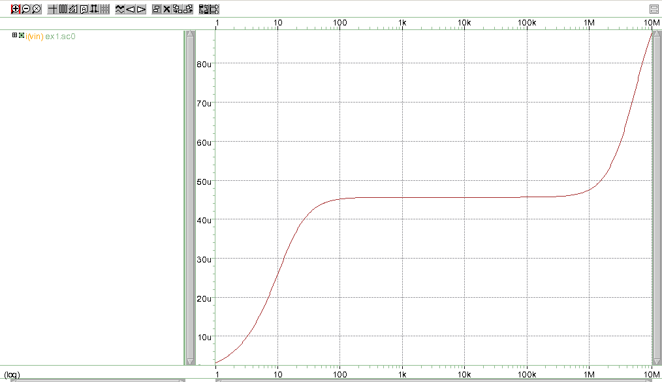

The second graph shows that it stays in cutoff until it reaches a threshold.

Exercise 2

